SIMATS ENGINEERING

ASSESSMENT TOOL 1: Agent Design Assessment

COURSE NAME: | ARTIFICIAL  INTELLIGENCE  AND EXPERT SYSTEMS | COURSE CODE: | MLA01

COURSE OUTCOME COVERED

CO1: Apply search algorithms and heuristic techniques to solve state-space search and optimization problems. (BTL 3)

Assessment Tool Weightage: 55 %

Total Marks: 50 Time: 60 Mins
No. of Questions: 1
Annexure A

Agent Design Assessment

Code of Conduct:

I Deepka V(192325008) (Name / Reg No) certify that this submission is my original work and that I have adhered to the guidelines specified for this assessment. I understand that any violation of academic integrity rules will result in disciplinary action.

Signature of the student:
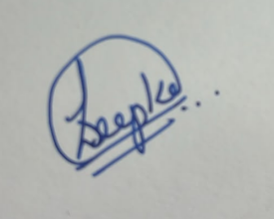

Question | Problem Understanding & AI Concept Identification | Dialogflow Agent Design & Implementation | Problem Formulation & Conversation Flow Design | Application of AI Techniques & Reasoning | Testing, Evaluation & Documentation | Total
Weightage | 20% | 30% | 20% | 20% | 10% | 100%
Q1

Signature of the Faculty Total Marks Awarded

Scenario
A university wants to develop an AI-based Student Support Assistant to provide instant responses to student queries related to course registration, timetable, examination schedules, attendance details, and campus services.
As an AI developer, design and implement a conversational agent using Dialogflow that can understand user requests, process intents, and provide appropriate responses.

Q. No. | Criteria to be evaluated | BL | Marks
1 | Problem Analysis and Agent Design: Analyze the student support problem and explain how Artificial Intelligence can solve the problem. Design the conversational agent by defining its objective, users, environment, inputs, outputs, and expected  performance measures. | BL3 | 10
2 | Dialogflow Agent Development: Create a Dialogflow agent by designing appropriate Intents, Entities, Training Phrases, Responses, and Contexts. Explain how the agent perceives user queries and generates responses. Provide screenshots of the implementation. | BL5 | 10
3 | Problem Formulation and Decision Flow: Represent the chatbot interaction as a problem-solving process by defining the initial state, user goal, possible actions, state transitions, and goal completion conditions. Draw the conversation flow diagram. | BL6 | 10
4 | Search Strategy Application: Analyze how search techniques used in AI problem solving can support conversational agents. Apply a suitable search approach (such as Breadth First Search or heuristic-based search) to model intent selection or dialogue navigation and justify your choice. | BL5 | 10
5 | Testing and Evaluation: Test the Dialogflow agent with different user queries. Evaluate accuracy, response quality, handling of unknown queries, and suggest improvements. | BL6 | 10

Evaluation Rubrics

Criteria | Weightage (%) | Excellent (Full Marks) | Good | Average | Poor
Problem Understanding & AI Concept Identification | 20% | 10 – Clearly analyzes the student support problem, defines AI application, agent objective, users, environment, inputs, outputs, and performance measures with proper justification. | 7.5 – Identifies most components of the agent design with minor omissions. | 5 – Provides basic problem analysis with limited explanation of agent components. | 0–2.5 –  Incomplete understanding of problem and agent design.
Dialogflow Agent Design &  Implementation | 30% | 10 – Successfully creates a functional Dialogflow agent with appropriate intents, entities, training phrases, responses, contexts, and explains interaction flow with screenshots. | 7.5 – Develops major Dialogflow components with minor configuration errors. | 5 – Creates basic intents and responses with limited entity/context utilization. | 0–2.5 –  Incomplete or incorrect Dialogflow implementation  .
Problem Formulation & Conversation Flow Design | 20% | 10 – Clearly represents chatbot interaction using initial state, goal state, actions, state transitions, goal conditions, and a  well-designed conversation  flow diagram. | 7.5 – Provides a structured flow with minor missing details. | 5 – Provides basic flow representation with limited explanation. | 0–2.5 – Poor or missing problem formulation and decision flow.
Application of AI Techniques & Reasoning | 20% | 10 – Correctly analyzes and applies suitable search strategies (BFS/heuristic search) for intent selection or dialogue navigation with strong justification. | 7.5 – Applies appropriate search strategy with reasonable explanation. | 5 – Provides basic understanding of search strategy application. | 0–2.5 – Unable to relate search concepts with conversational agent.
Testing, Evaluation & Documentation | 10% | 10 – Performs comprehensive testing using multiple user queries, evaluates accuracy, response quality, unknown query handling, and suggests meaningful improvements. | 7.5 – Performs adequate testing and provides evaluation with minor gaps. | 5 – Conducts limited testing with basic observations. | 0–2.5 –  Insufficient testing and evaluation.

Assessment Response
1. Problem Analysis and Agent Design
The Student Support Assistant gives instant support for course registration, timetable, examination schedules, attendance and campus services. Its objective is to reduce repetitive manual enquiries and provide consistent support. Users are university students; the environment is the university digital/ERP ecosystem. Inputs are natural-language queries and outputs are relevant guidance or information. Performance measures include intent accuracy, response relevance, response time, fallback rate and successful task completion.
2. Dialogflow Agent Development
The agent contains intents for Attendance, Campus Services, Course Registration, Exam Schedule and Timetable, along with Welcome and Fallback intents. Entities such as course, department and semester extract parameters. Training phrases cover different forms of student queries, responses provide suitable guidance, and contexts maintain state for follow-up interactions. Implementation screenshots are shown below.
3. Problem Formulation and Decision Flow
Initial state: student submits a query. Goal state: correct information is delivered. Actions: detect intent, extract entities, request missing parameters, select a response, or trigger fallback. State transitions are: User Query → Intent Detection → Entity/Parameter Extraction → Response Selection → Goal Completion. If confidence is low, the agent moves to the fallback state and requests a clearer query.
Conversation flow: Student Query → Intent Detection → Select Course Registration / Timetable / Exam Schedule / Attendance / Campus Services → Generate Response → Goal Completed.
4. Search Strategy Application
A heuristic-based search is appropriate for intent selection because the agent ranks likely intents according to how closely the query matches trained examples and selects the strongest valid match. This is more efficient than exploring every dialogue path. BFS is useful conceptually for menu-style navigation where alternatives at the current dialogue level are examined before deeper branches.
5. Testing and Evaluation
Test queries include: “How do I register for courses?”, “Show my timetable”, “When is my exam?”, “What is my attendance?” and “What services are available on campus?”. Correct intent matching and relevant answers indicate good response quality. Unknown queries are handled by the Default Fallback Intent. Improvements include more training phrases, live ERP integration using fulfillment, authentication for personal attendance data, multilingual support and analysis of low-confidence queries.

Intents

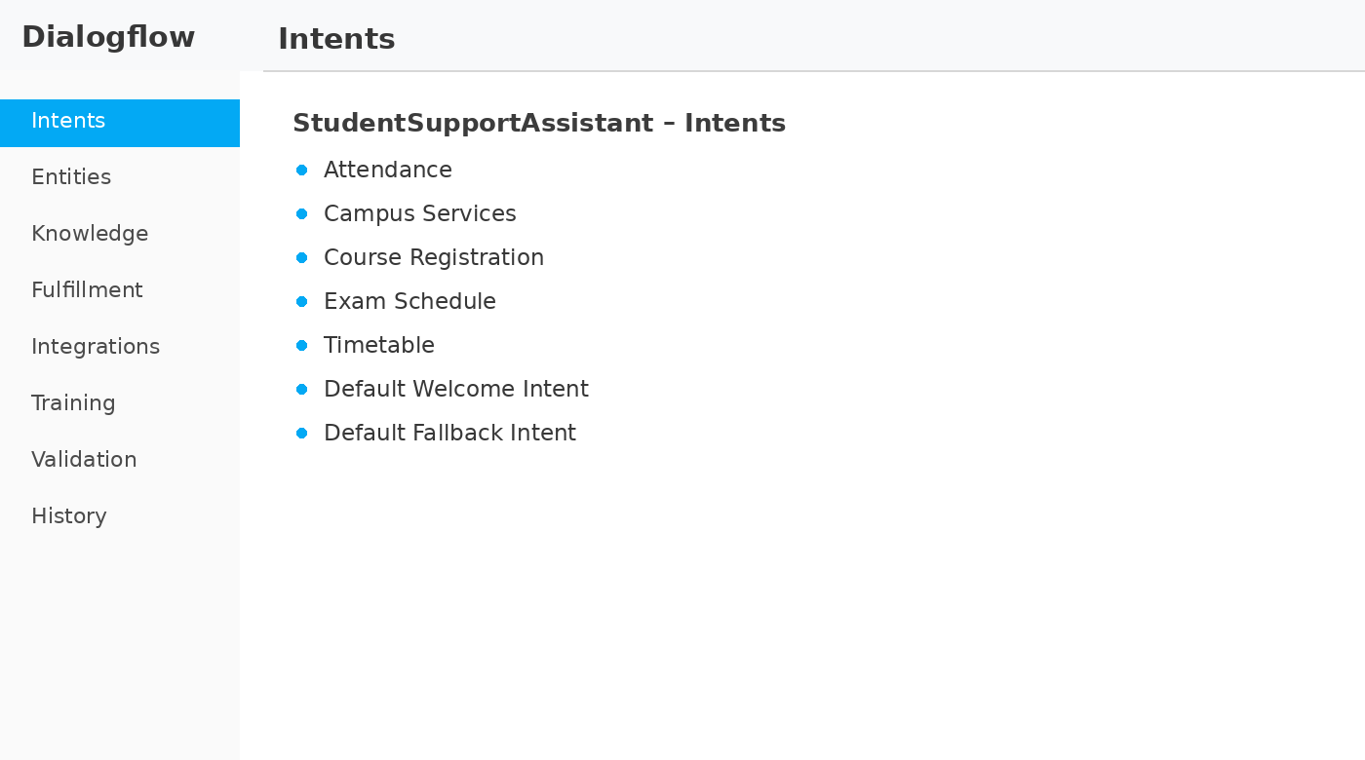

Entities

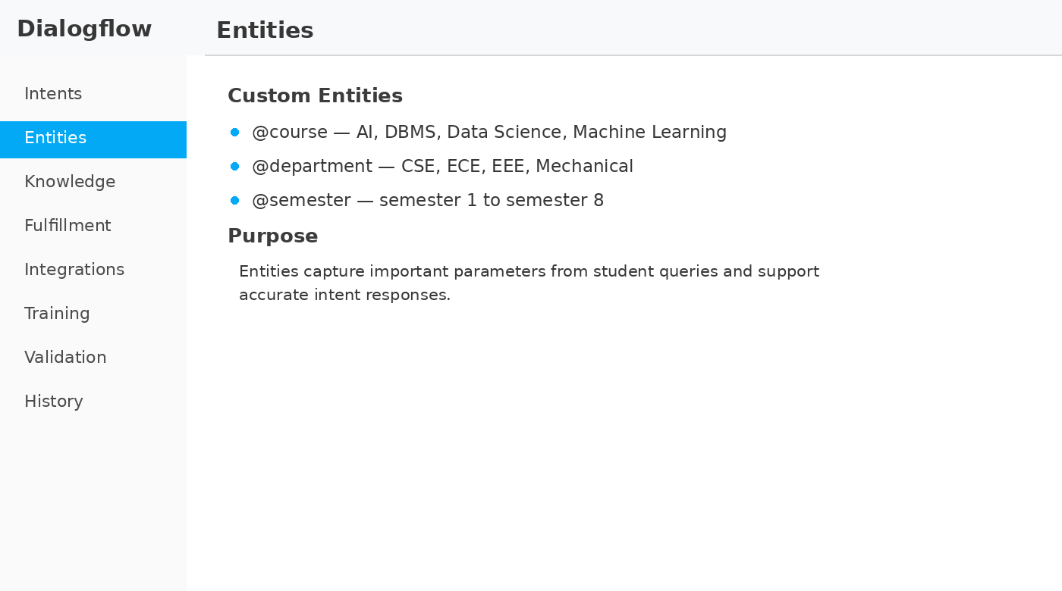

Course Registration

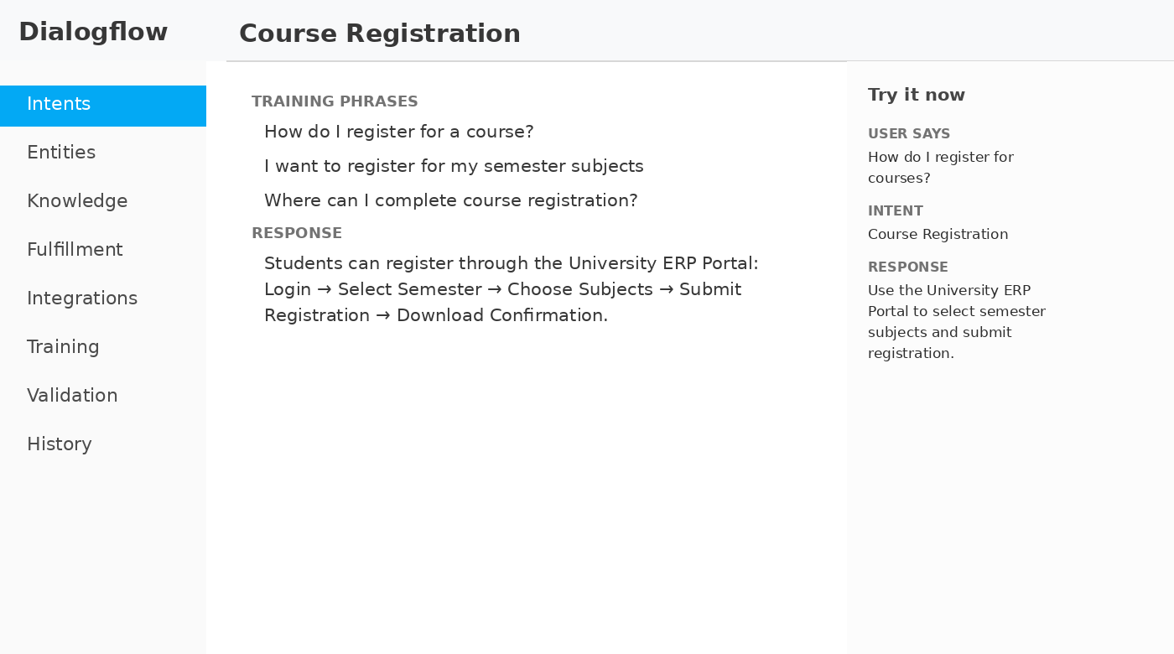

Campus Services
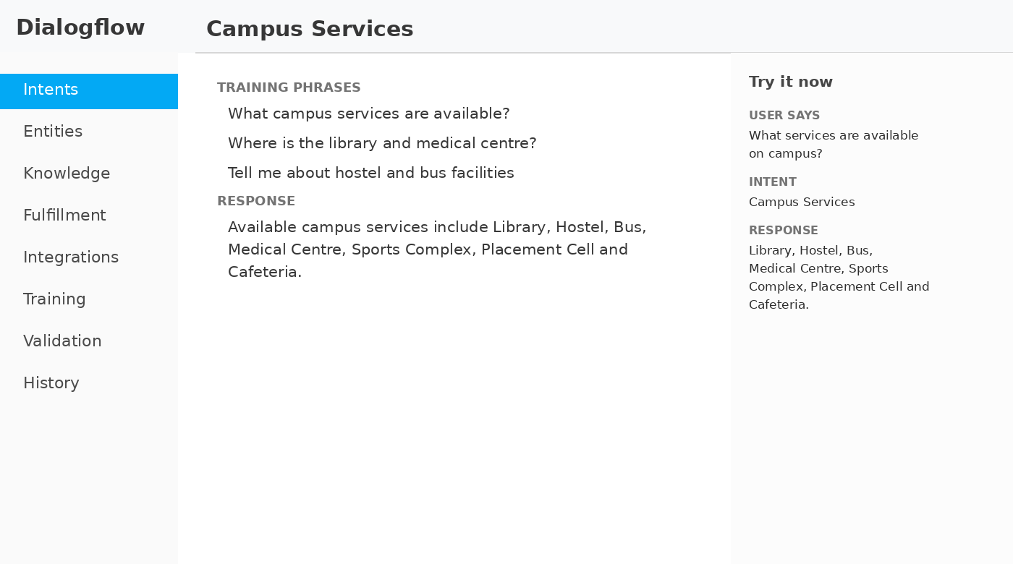

Time Table
